DCOM 142 Introduction to Linux/Unix
Lesson 13: Implementing Simple Scripts
Lab 13: No Assisted Lab: Scripts
Using if – else condition and special variables
- Write a script, “lab_13a.sh” to accomplish the following tasks:

  - This script takes user argument from keyboard for directory entry and checks whether that directory exists in the home directory.
  - If the directory exists, display the following:
The directory, {directory name} exits
  - If the directory is not present, display the following:
The directory, {directory name } does not exist.
Take a screen shot of your script, “lab_13a.sh” and the output after the script is run
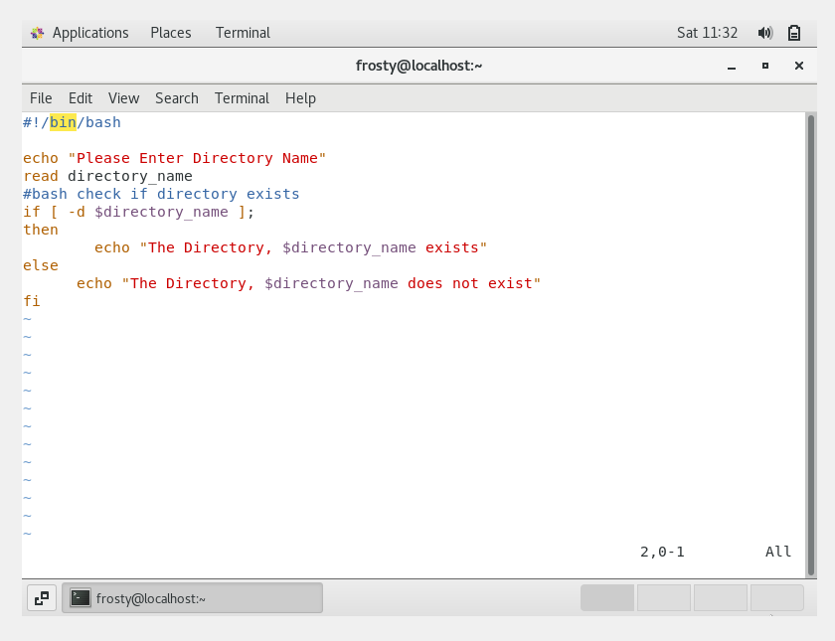
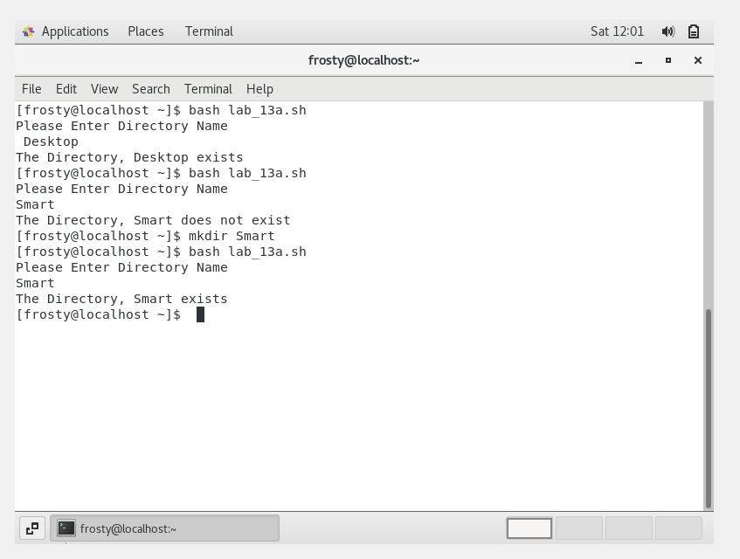
- Write a script, “lab_13b.sh” to accomplish the following tasks:

  - This script takes user argument from keyboard for the username.
  - If the logged in user is, student, print the following, “Welcome message to the logged in with the username printed”
  - If the logged in user is not student, then print the following, “Print the currently logged in username is not student”
  - Run the script.
Take a screen shot your script, “lab_13b.sh” and the output after the script is run
